CV Form for Internship
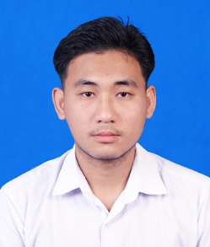

Personal Info

Name: | Mg Aung Myint Tun
Date of Birth: | March 23, 2003
Address: | Thaton Township, Mon State
Email: | aungmyinttun2003@gmail.com
Contact Number: | 09446895128

Education

Year: | Final year
Major: | Computer Science
University: | University of Computer Studies(Thaton)
Graduation Expectation: | January 2027

Technical Skills
- Flutter, Dart, MySQL(Major)
- Laravel , PHP (Intermediate)
- Java, Spring Boot (A little)

Language Skills
- English (Intermediate)
- Myanmar

Project Experiences
2022-2023 | Job Net (Java,J2EE)
2022-2023 | Tiny box of Beauty (JavaScript)
2023-2024 | Shwee Shaung News (PHP)
2023-2024 | Shwee Shaung Space (Spring Boot)
2023-2024 | Fresh Shop (C#)
2024-2025 | Facial Emote (Python)
2024-2025 | Online Voting System (PHP)
2024-2025 | Nobel Gold Application (Flutter)

Certificates
- Completion Certificate in AWS Educate Foundational Course (2025)
- 2023-2024 UCSTT Project Show (Consolation Prize)
- 2024-2025 UCSTT Project Show (Second Prize)

Activities
- Volunteer : 2024-2025 UCSTT Fresher Welcome Ceremony
- Developer: 2024-2025 UCSTT Fresher Welcome Ceremony’s Online Voting System
- Member: UCSTT Karen Family
- Contestant: (2023-2024) UCSTT Project Show
- Contestant: (2024-2025) UCSTT Project Show

Field Experiences
- Data collecting from May May Zin Jewelry shop for Nobel Gold Application (2024-2025) UCSTT Project Show

Work Experience
- Vendor at Snack Shop from Mawlamyine Market
- Delivery Service at ‘Yaung Sin Ni Trading’ (From 10.5.2021 To 10.5.2022)
My Portfolio
- Aung_Myint_Tun

